UI GreenMetric World University Rankings (UIGWURN) Report 2025
Please complete this country report according to your activities as national coordinator on UIGWURN during 2024-2025. This report will be presented by the national coordinator(s) at UIGWURN Steering Committee Meeting on 17 June 2025 in Nice, France..
Country : Kazakhstan
National Coordinator (s) : Kazakh National Agrarian Research university

- General Report
- Activities:
- Shaping Global Higher Education and Research in Sustainability
- Creating Global Sustainability Leaders
- Partnering on Solutions to Sustainability Challenges
- Table Activities in 2024
No | Programs | Total Participants | Photo | Short Description
1 | UI GreenMetric Course on Sustainability 2024  (March 2024)  Model UN KazNARU | 60 | 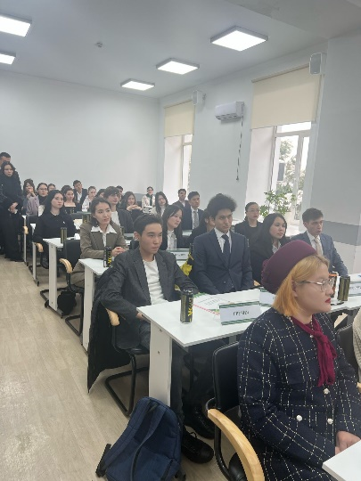  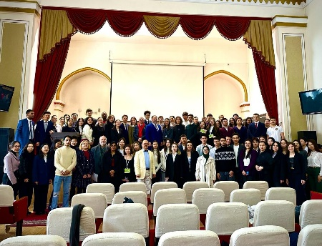  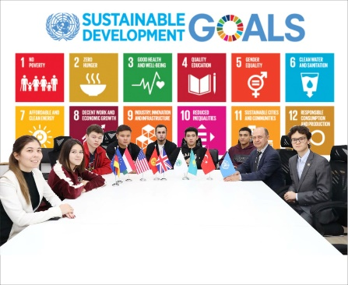 | On March 2, 2024, the Kazakh National Agrarian Research University (KazNARU) hosted an international conference "Model United Nations". This conference was organized to commemorate Kazakhstan's accession to the UN and its contribution to the implementation of the Sustainable Development Goals (SDGs). The conference's theme was "Implementation of the SDGs and global challenges: Kazakhstan's contribution". The event aimed to engage students and raise their awareness about the importance of working with global challenges and SDGs, through diplomatic negotiations among students. Over 120 students from various universities in Almaty, such as KazNU, KIMEP, UIB, Turan, Ablai Khan University, etc., participated in the conference, representing different specialties such as economics, management, and applied sciences.  Model UN is a popular international program in a brainstorming and student conference format that replicates the work of the United Nations. For one day, students transform into diplomats and heads of state, acting as representatives of the UN. On March 2, 1992, at the plenary session of the 46th session of the United Nations General Assembly, the Republic of Kazakhstan officially joined the UN, becoming a full-fledged subject of international relations. Almost exactly a year later, on the memorable date of February 16, 1993, the first office of the UN representative office in Kazakhstan was opened in the architectural monument of our republic, the Kazakhstan Hotel in Almaty. The first UN Permanent Representative to the Republic of Kazakhstan was Mr. Nigel Ring.  For more than 30 years, Kazakhstan has maintained a balanced and multi-faceted foreign policy that wholeheartedly supports the United Nations' efforts to address global challenges. Kazakhstan values the UN's indispensable role in shaping international relations and it is proud to have established 21 UN agencies in the country (including FAO, UNDP, UNESCO, etc.), working together to implement meaningful projects across various sectors. These enduring and fruitful partnerships with the UN have enabled Kazakhstan to make a significant contribution to the work of global community on implementation of SDGs, and the country remains committed to working alongside the UN to build a better world for all. life.  The following were invited to present the opening of this event: Representative of UN Global Communications in Almaty - Mr. Vlastimil Samek, Representative of the US Consulate General in Almaty - Mr. Chad Kinnear. Representatives of FAO, project coordinator - Ms. Aizhan Karabaeva and consultant for developing partnerships - Ms. Gulnaz Iskakova. The director of the Italian Cultural Center is Mr. Carmine Barbaro. EFES Kazakhstan was a business partner and co-sponsor.  The event was organized as a part of activities of "Green Campus" program, which is being carried out with the support of the International Institute of Green and Sustainable Development and KazNARU's International Office. It's worth noting that the program aims to promote sustainability and environmental friendliness within the campus.
2 | Greenmetric Workshop Gamifying Sustainability: Transforming Plastic Collection into Engaging Campus Activities | 30 | 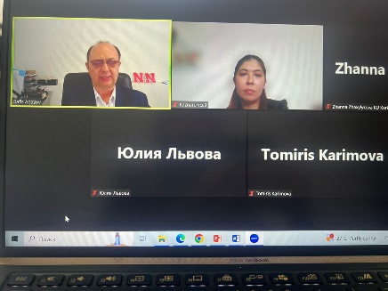 | 1. Introduction and Workshop Objectives  - *Welcome and Opening Remarks*: Brief introduction to the workshop and its significance.  - *Objectives Overview*: Outline what participants will learn and achieve by the end of the session.  - *Speaker Introductions*: Present the facilitators and their backgrounds in gamification and sustainability.  2. Understanding Gamification and Sustainability  - *What is Gamification?*: Introduction to gamification principles and how they can be applied to non-game contexts.  - *Sustainable Campus Initiatives at KazNARU*: Overview of sustainability goals and the importance of plastic reduction on campuses.  - *Case Studies of KazNARU*: Examples of successful gamification in sustainability efforts in plastic collection  3. Designing a Gamified Plastic Collection Program  - *Key Elements of Gamification*: Points, badges, leaderboards, challenges, and rewards.  - *Interactive Workshop Activity*: Breakout into groups (if possible online) or use collaborative tools to brainstorm and design a gamified plastic collection initiative tailored to their campus.  - *Presentation and Feedback*: Groups share their ideas, followed by feedback from facilitators and peers.  4. Implementation Strategies and Tools  - *Digital Tools and Platforms*: Overview of tools that can be used to implement and manage the gamification program (e.g., mobile apps, web-based platforms).  - *Incentives and Engagement*: Discuss how to keep participants motivated and engaged long-term.  - *Measuring Success*: Key metrics and methods for evaluating the impact of the program.  5. Q&A and Next Steps (30 minutes)  - *Open Floor Q&A*: Participants ask questions and share their thoughts.  - *Action Plan Development*: Guide participants on creating a step-by-step action plan to implement their ideas.  - *Closing Remarks and Resources*: Summarize key takeaways, provide additional resources, and outline the next steps for continued learning and implementation.  CONCLUSION Additional Notes:  - *Interactive Elements*: Use online tools like polls, Q&A sessions, and breakout rooms to maintain engagement.  - *Follow-Up Resources*: Provide participants with a handout or digital resource pack summarizing key points and offering further reading or tools.
3 | KazNARU WAS AMONG THE WINNERS IN THE NATIONAL SDGS COMPETITION | 50 | 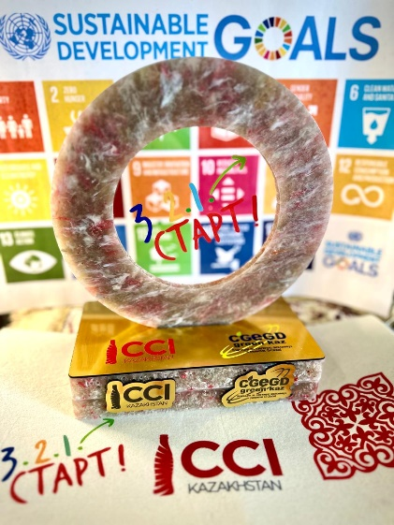  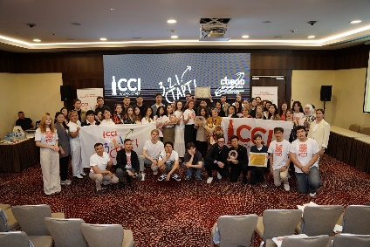   | АSTANA. On June 7 this year, KazNARU achieved significant success by receiving a prestigious award for participating in a national competition for collecting plastic and promoting sustainable development. A competition organized by the Coalition for Green Economy and Development G-Global with the support of CCI Kazakhstan. The competition aims to encourage educational institutions to adopt environmentally responsible practices and raise awareness of the importance of plastic recycling and involved many universities from around Kazakhstan.  Throughout the academic year from September 2023 to May 2024, students, faculty and staff of the university actively participated in collecting plastic waste. Plastic bins were installed throughout campus, allowing the university to collect more than 1,300 kilograms of plastic bottles, packaging and other single-use items. This result was one of the best among all participants in the competition and underscored the university's commitment to environmental responsibility.  Winning the competition is also associated with the university's extensive program to promote sustainable development. The university has implemented a number of initiatives aimed at reducing its environmental impact. As part of the program, the Institute for Green and Sustainable Development organized a series of lectures “Foundation of the Sustainable Development”, coordinated seminars and workshops within the framework of the United Nations Academic Impact (UNAI) and international Greenmetric rating, and conducts other events on the topics of sustainable consumption, recycling and waste minimization. Particular attention was paid to introducing zero waste concepts and reducing the use of plastic in everyday life.  A key element of success was the active participation of the university community. More than 2,000 students and staff took part in various events related to the competition. This not only helped the university achieve high results, but also contributed to the development of a culture of sustainable consumption and responsible attitude towards nature among young people.  In recognition of its achievements, the university received a cup as one of the best universities in the field of sustainable development and Environmental Sustainable Governance (ESG). This award was presented at a ceremony in the presence of representatives of the Ministry of Ecology and Natural Resources and the Majlis, as well as leading environmental organizations of the country. The award certainly inspires our students to develop further environmental initiatives and research in the areas of recycling and sustainable development. On behalf of the students of KazNARU, student Ayalym Niyazbek received the award.  Receiving this award was an important milestone in the development of the university's sustainability strategy. University management plans to continue working to expand environmentally responsible practices and strengthen interaction with the local community to promote sustainable development ideas.

No | Programs | Scope (international / regional / national / local / etc) | Total Participants | Photo | URL | Short Description
1 | UI GreenMetric Online Course on Sustainability 2021  (September 2021 – January 2022) | International | 30 Teachers  89 Students | 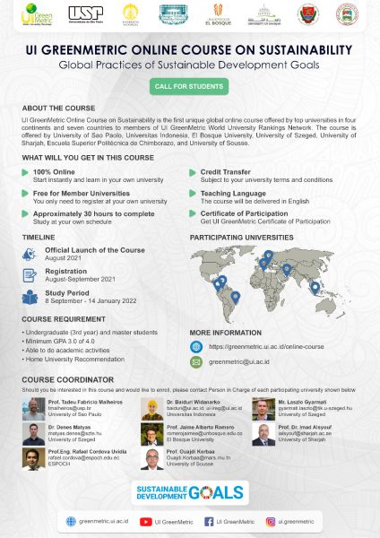 | https://greenmetric.ui.ac.id/online-course
2 | Program to build windmills as a power plant in the village of Bungin | Surrounding communities | ... | 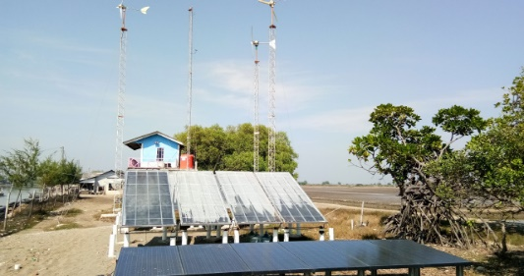 | http://pantaibakti.desa.id/2019/04/28/kampung-bungin-objek-wisata-bahari-berbasis-taman-teknologi/ | Faculty of Engineering of Universitas Indonesia build windmills as a power plant in the village of Bungin. With these windmills the village is able to produce electricity around 1000 watts/hour.

- Challenges and Future Plans
Example:
- National Workshop of UI GreenMetric for …. Universities on (the date of event), 2025/2026
- Other plans

Impact and Future Directions
The implementation of the "GREEN CAMPUS" program has had a significant
Positive impact on KazNARU’s campus and community. The increased greenery, reduced carbon emissions, and heightened awareness of sustainability practices have contributed to a healthier and more environmentally conscious Campus. The success of the program has set a benchmark for other universities 112 Kazakhstan, inspiring them to develop their own Green Campus projects.
Mowing forward, KazNARU plans to expand the scope of the Green Campus program by introducing new initiatives, enhancing existing ones, and fostering greater collaboration with local and international partners. Continuous monitoring and exhalation will ensure the program's effectiveness and identify areas for improvement.
Conclusion
The "GREEN CAMPUS" program at KazNARU has successfully implemented a comprehensive action plan 2024-2025 aimed at fostering sustainability and environmental consciousness. Through various initiatives and events, the program has engaged the campus community, promoted sustainable practices, and contributed to the achievement of the Sustainable Development Goals.
The positive impact of the program is evident in the increased greenery, reduced carbon emissions, and heightened awareness of sustainability practices. KazNARU remains committed to building a sustainable future and setting a benchmark for other universities in Kazakhstan. Together, we can make a difference today for a sustainable tomorrow.

- Comments

Prepared by Rafis Abazov and Maiya Suyunchaliyeva

